Nicholas Sammut

CSC 425 – Mobile Computing

Dr. Mark Allison

Homework 2

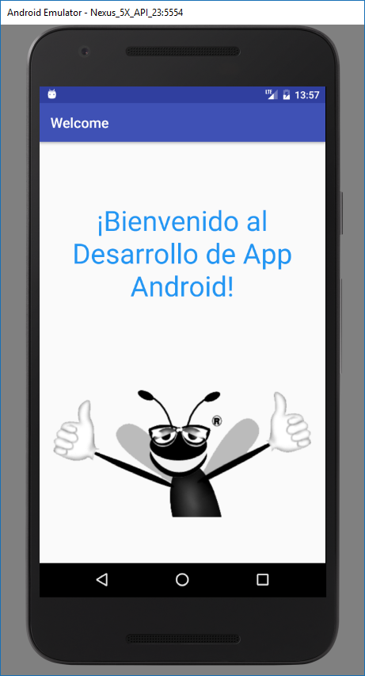

Image of Emulator Running (Spanish Locale)

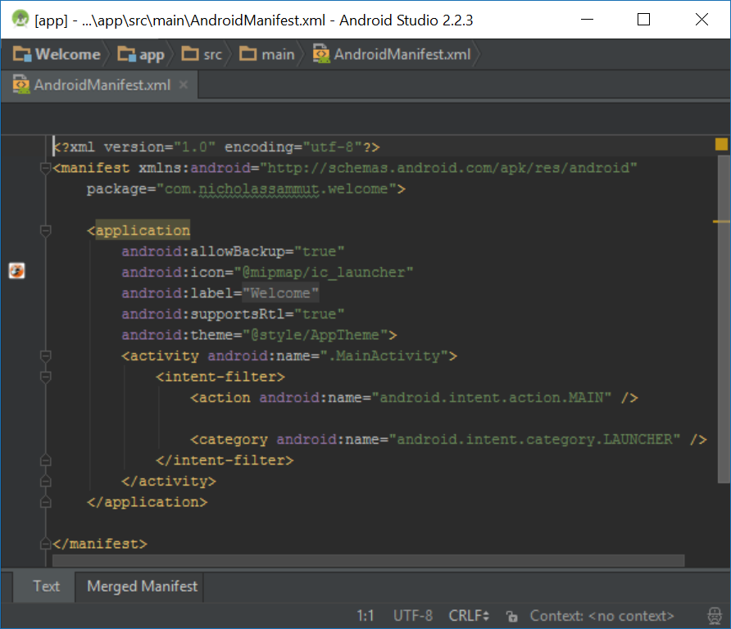

­Image of Android Manifest File

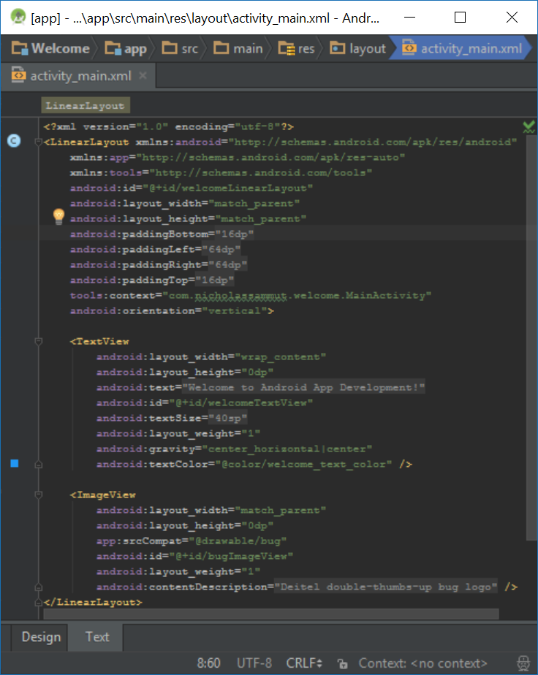

Image of activity_main.xml